Report on DIFM Field Trial

# Head1: Field Management Information

## Head2

### Head3

* Baseline seed rate: 110 K seeds.
* Seed target rates: 70K, 85K, 100K, 115K, 130K, 145K, 160K, 170K
* Planter width: 60 feet
* Harvester width: 25 feet

# Summary

A soybean seed rate trial was conducted on the Bohnhoff_Tims field in crop year 2020. The trial was implemented with a high level of accuracy. The best estimate provided by the data and model is that, under growing conditions identical to those of the field in 2020, implementing the recommended site-specific seeding rate strategy would have increased profits by approximately $46 per acre. The data and model placed a 95% level of statistical confidence that this profit gain would have been between approximately $29 and $63 per acre.

# Economic Results and Implications

* Crop price: $14/bu
* seed price: $0.321/K seeds

Figure 1 shows the analysis’s recommended site-specific seed rate map. The figure was calculated using data from each management zone separately. (Details about how management zones were determined are provided later in this report.) A generalized additive model (GAM) regression was used to model yield as a function of seed rate in each zone, and then given that model estimation, the profit-maximizing seed rate was found for each zone. Table 1 lists for each zone the estimated per-acre yields that would have resulted, given the year’s growing conditions, from applying the grower-chosen seeding strategy and the estimated optimal seed rate derived from the data and model.

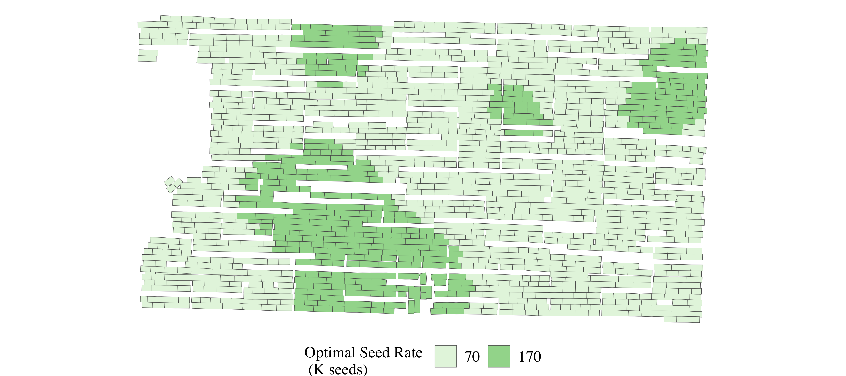

Figure 1: Estimated Optimal site-specific seed rate Rx

Table 1: Summary yield and seed rate data by zone

| Zone | Strategy | Yield (bu/acre) | Seed Rate |
| --- | --- | --- | --- |
| Zone 1 | Grower-chosen | 38 | 110 |
| Optimal site-specific | 46 | 70 |
| Zone 2 | Grower-chosen | 54 | 110 |
| Optimal site-specific | 48 | 70 |
| Zone 3 | Grower-chosen | 61 | 110 |
| Optimal site-specific | 48 | 70 |
| Zone 4 | Grower-chosen | 38 | 110 |
| Optimal site-specific | 48 | 170 |

If the grower had not participated in the experiment, the chosen strategy would have been to apply seed uniformly across the field at 110 K seeds per acre.

The model predicts that this strategy was approximately 40 K seeds per acre too high in Zone 1, 40 K seeds per acre too high in Zone 2, 40 K seeds per acre too high in Zone 3, 60 K seeds per acre too low in Zone 4.

For each zone, Figure 2 compares the differences in per-acre net revenues that would have resulted from different management strategies. (Net revenues equal revenues from soybean sales minus seed costs.) For Zone 1, the best estimates of the gain in net revenues when switching from the grower’s chosen rate of seed K seeds per acre would have been $81.1. Of course, as with any statistical data analysis, there cannot be 100% certainty that the actual difference in net revenues from the two management plans would end up being exactly $81.1. The black brackets centered over Zone 1’s red circle illustrates that a 95% level of statistical confidence that the different in net revenues would have been between $27.2 and $135

A formal statistical test (called a t-test) established with a strong level of statistical confidence that net revenues would indeed be greater at the 70K rate than at the grower-chosen rate of 110 K seeds (t-value of 2.95).

For Zone 2, the best estimate of the gain in net revenues when switching from the grower’s chosen rate of 110 K seeds per acre to the recommended rate of 70 K seeds would have been approximately $24.6, as is shown by the height of the red circle. The black brackets centered over Zone 2’s red circle illustrates that a 95% level of statistical confidence that the difference in net revenues would have been between $4.85 and $44.36. A formal statistical test (called a t-test) established with a strong level of statistical confidence that net revenues would indeed be greater at the 70K rate than at the grower-chosen rate of 110 K seeds (t-value of 2.44).

For Zone 3, the best estimate of the gain in net revenues when switching from the grower’s chosen rate of 110 K seeds per acre to the recommended rate of 70 K seeds would have been approximately $8.41, as is shown by the height of the red circle. The black brackets centered over Zone 2’s red circle illustrates that a 95% level of statistical confidence that the difference in net revenues would have been between $-13.65 and $30.48. A formal statistical test (called a t-test) established with a negligible level of statistical confidence that net revenues would indeed be greater at the 70K rate than at the grower-chosen rate of 110 K seeds (t-value of 0.75).

For Zone 4, the best estimate of the gain in net revenues when switching from the grower’s chosen rate of 110 K seeds per acre to the recommended rate of 170 K seeds would have been approximately $70.79, as is shown by the height of the red circle. The black brackets centered over Zone 2’s red circle illustrates that a 95% level of statistical confidence that the difference in net revenues would have been between $42.06 and $99.52. A formal statistical test (called a t-test) established with a strong level of statistical confidence that net revenues would indeed be greater at the 170K rate than at the grower-chosen rate of 110 K seeds (t-value of 4.83).

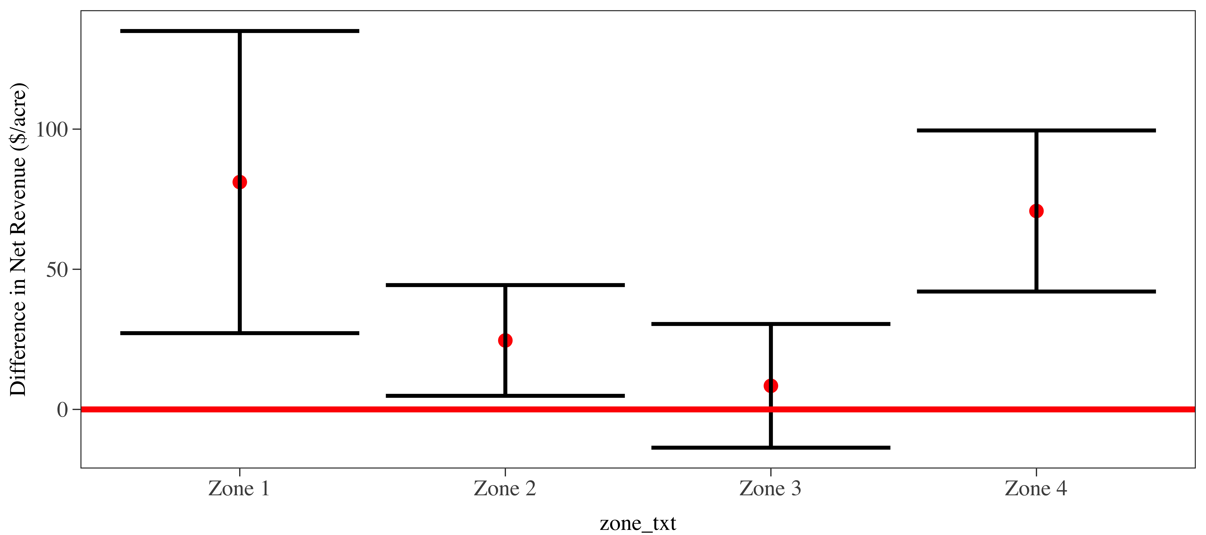

Figure 2: Confidence intervals of the difference in net revenues under grower-chosen (110 K seeds) vs. optimal site-specific seeding strategies by zone

Figure 3 shows confidence intervals of the gains in net revenues achieved by changing management strategies across the whole field. The data and model’s best estimate of that implementing the recommended site-specific seeding strategy would result in a profit gain of approximately $46 per acre. The confidence interval shows that the evidence that the site-specific strategy is more profitable than the grower-chosen strategy is strong. The data and model provide strong evidence that the optimal variable rate strategy would result in greater profits than those from the optimal uniform rate strategy; the point estimate of that profit difference is approximately $29 per acre. The third confidence interval in the figure shows that the data and model strong evidence that the optimal uniform rate strategy of approximately 74K seeds per acre would lead to higher profits than would the grower-chosen strategy of 110 K seeds. The point estimate of that profit difference is approximately $17.

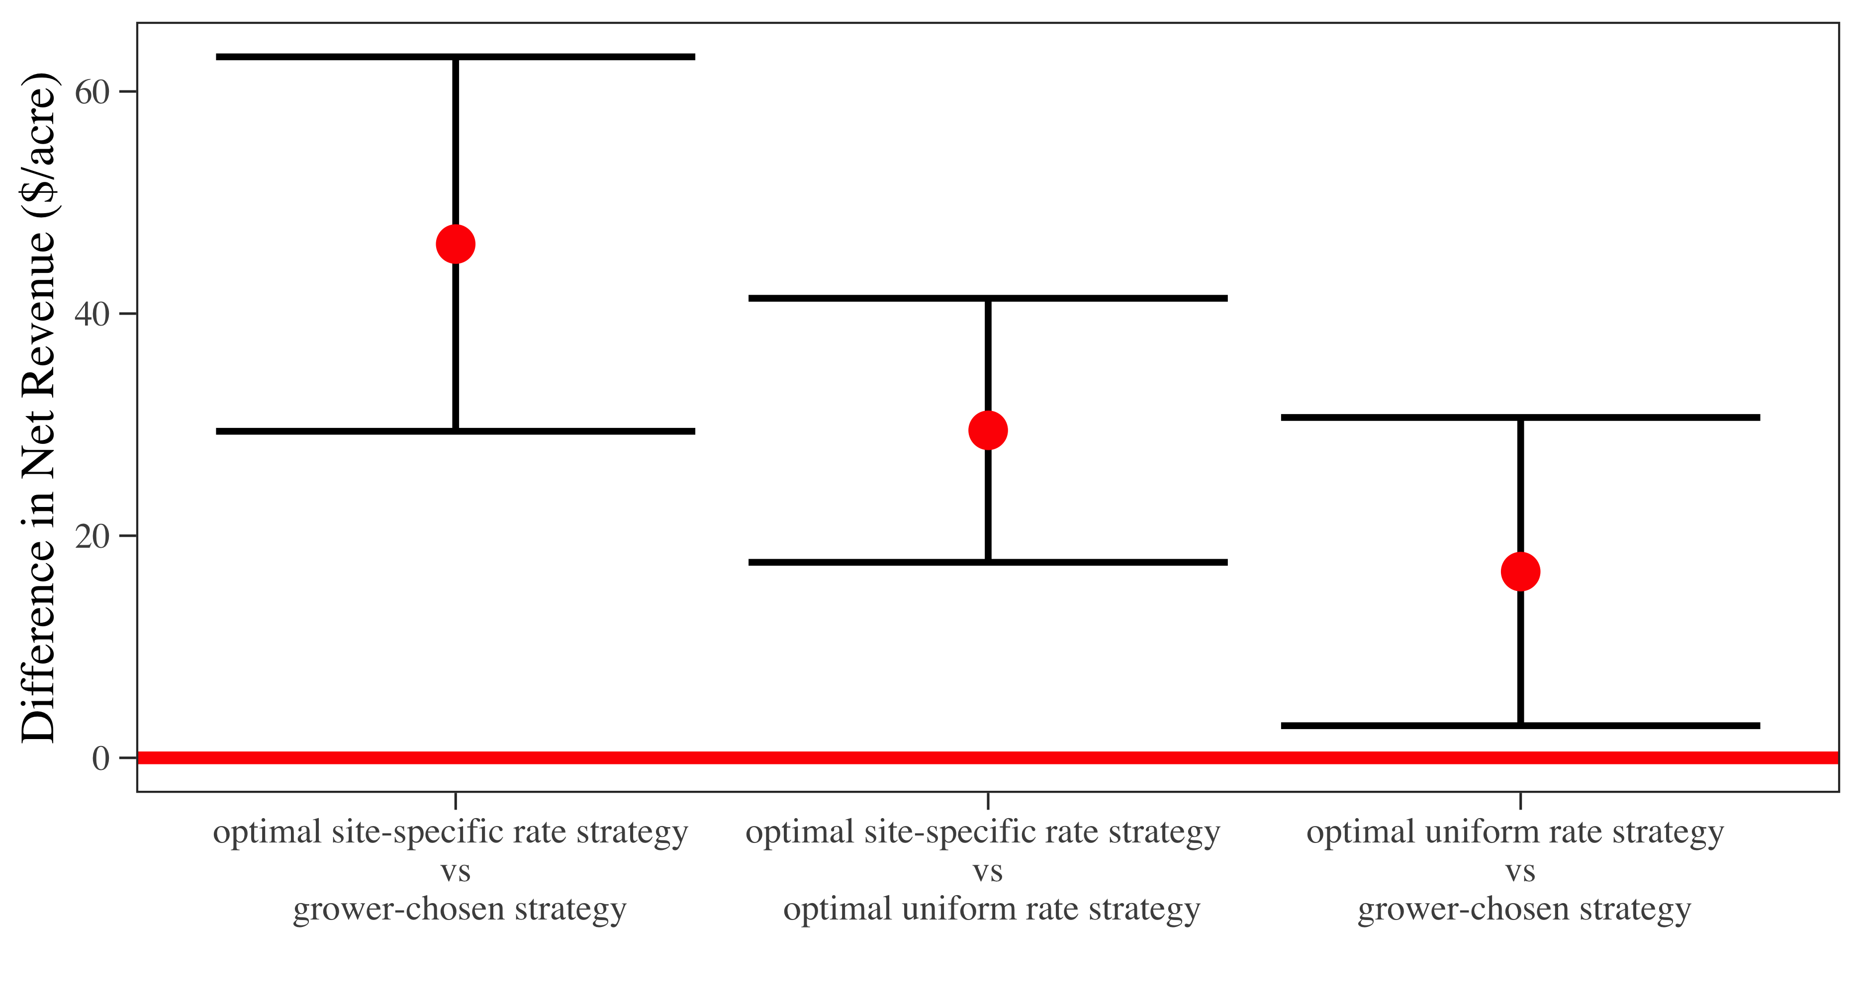

Figure 3: Confidence intervals of whole-field profit differences, by management strategy

# Trial Design and Implementation

Figure 4 displays the trial design and the resultant as-planted map. Casual observation shows that .

The field’s status quo seeding plan (that is, the one that would have been used had there been no field trial conducted) was to apply 110 K seeds per acre uniformly across the field. *num_exp_rates_here* experimental seed rates were assigned randomly and in roughly equal number to plots.

Plots were all 60 feet wide. Plot were all between and feet long. A rate of per acre was assigned to a buffer zone around the perimeter of the trial, but observations from the buffer zone were not included as part of the trial in later analysis. Figure 4 pairs the trial’s design, as-planted, and yield maps.

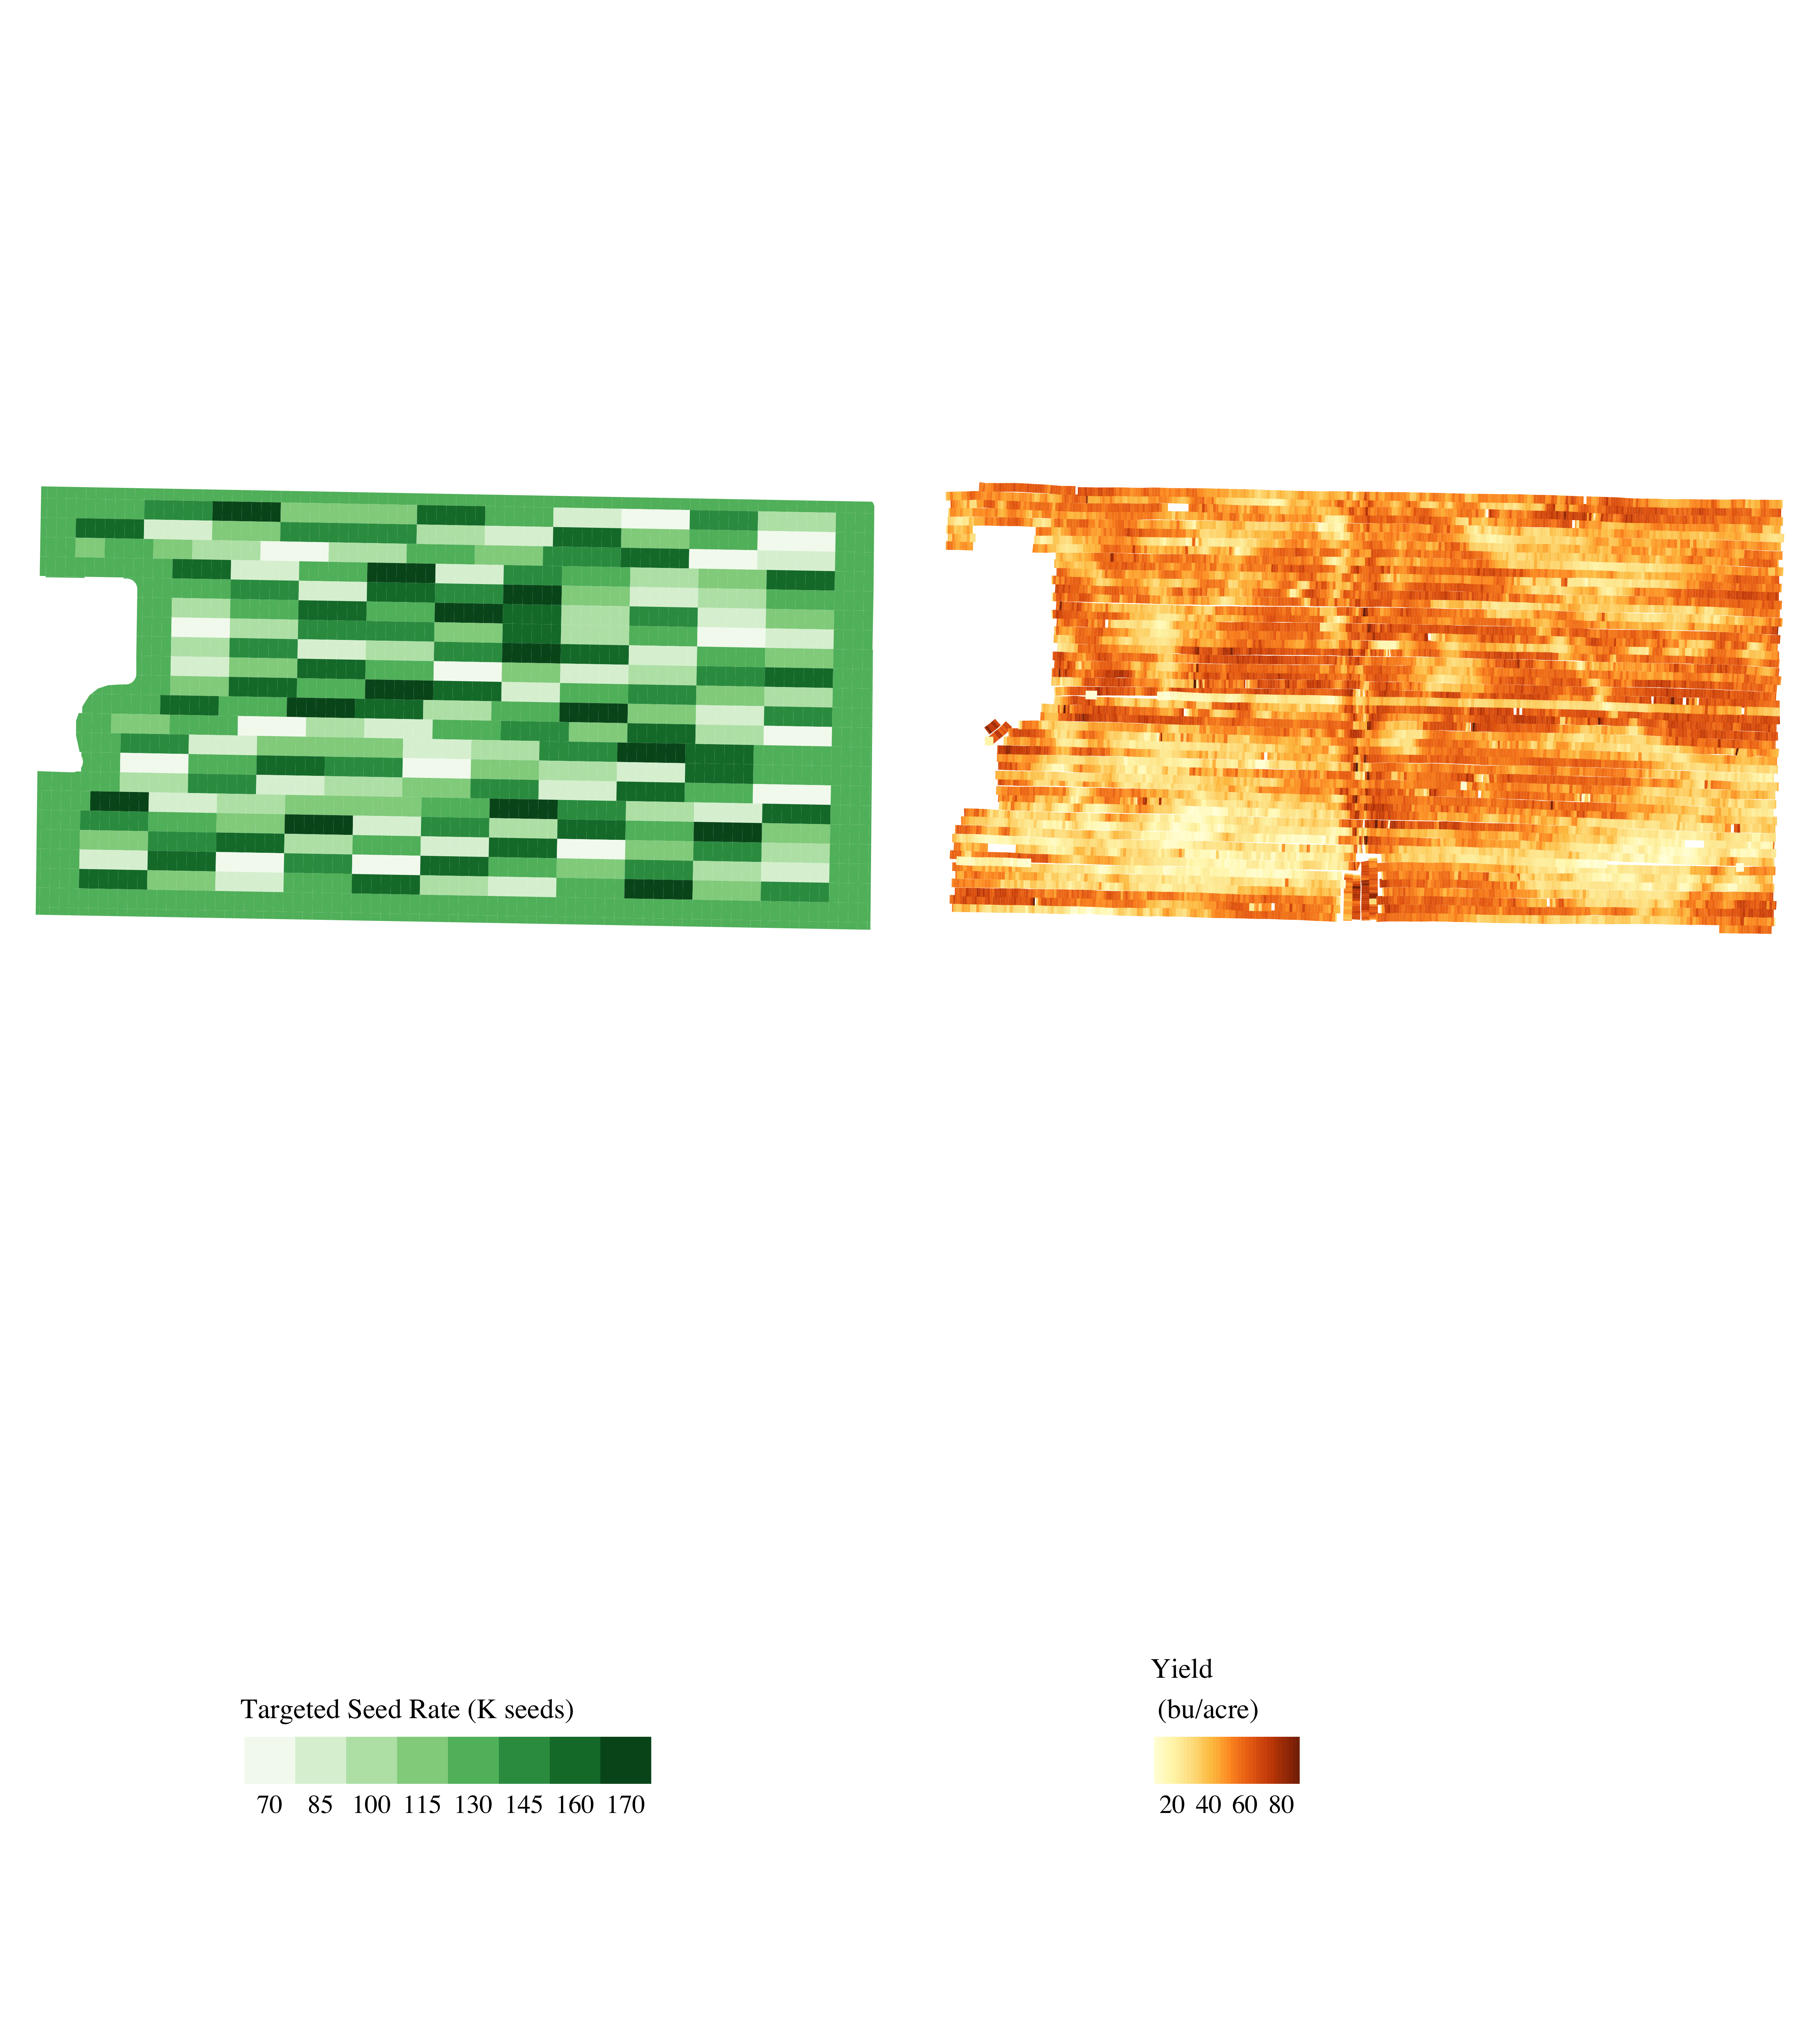

Figure 4: Trial design, as-planted nitrogen rates, and soybean yields, 2020)

# Defining Management Zones Using a Statistical Parameter

Management zones were identified using a statistical model that assumed that, on each field site $i$ in the field, yield response to seed rate took on the following form:

$$Yield_{i}=α_{i}+β_{i}ln(Seed)+v_{i}.$$

The $β$ parameter is an estimate of the percentage change in yield give a 1% change in seed rate. A higher $β_{i}$ estimate predicts a higher yield response to seed rate at site $i$, which implies a higher economically optimal seed rate at that site. Using a statistical technique called geographically weighted regression (GWR), a value of the beta parameter was estimated at each observation of the field’s processed data. Figure 5 displays the map of the values of $β$ on the field.

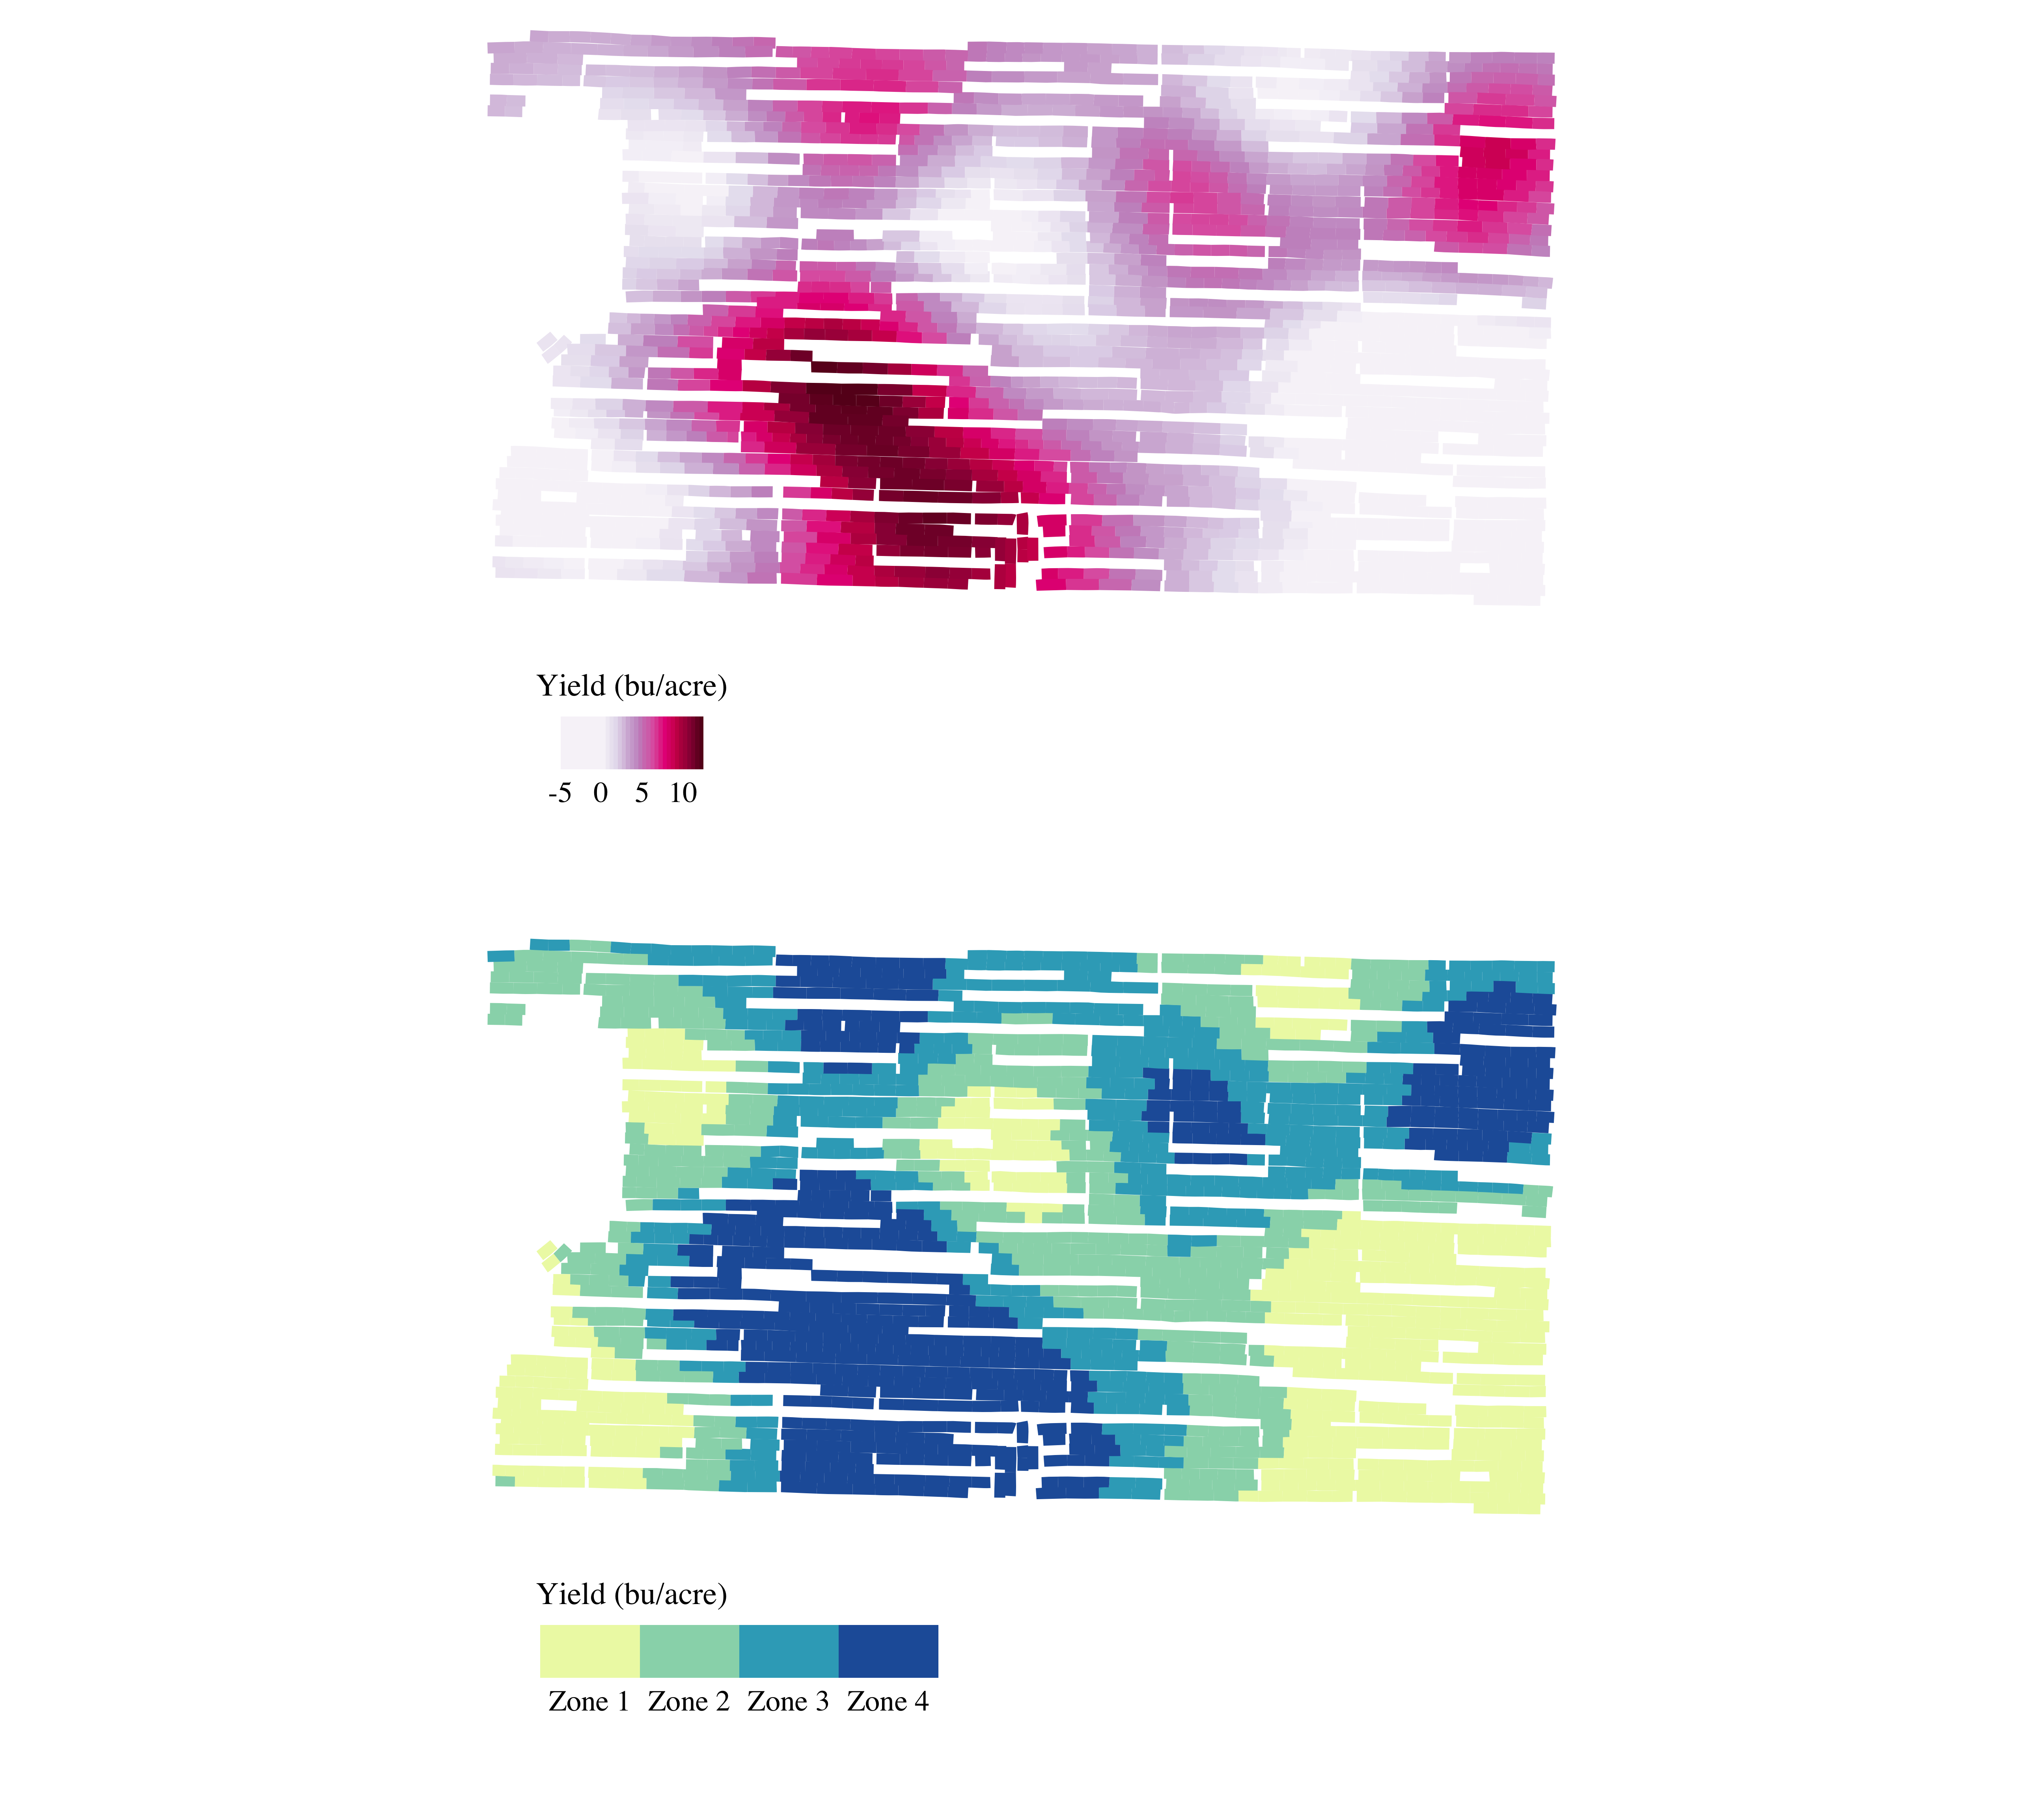

Figure 5: Map of the estimated values of the yield response parameter, $β$ the derived management zone

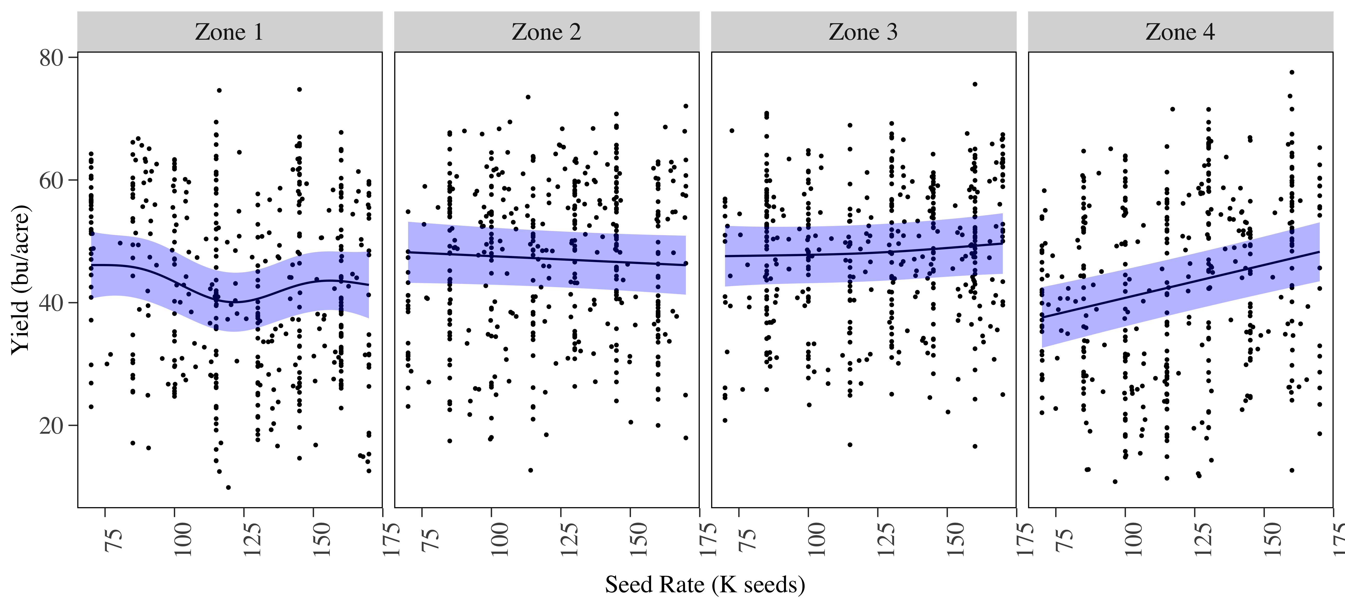

Figure 6: (Seed rate, yield) data points for each management zones, and the estimated yield response curves derived from them

The values of $β$ in all of the field’s observation points were partitioned into 4 “zones,” with Zone 1 consisting of the observation points in the lowest fourth of estimated values of $β$, and Zones 2, 3, and 4, containing the observations points from second, third and fourth fourths. The bottom panel of Figure 5 displays those zones. Figure 6 shows the zones’ (seed rate, yield) scatterplots and estimated yield response curves, which were produced using General Additive Model regression techniques.

# Exploring Interactions between Seed Rate and Field Characteristics in the Yield Response Function

The discussion thus far has offered statistical evidence of how yield responses and optimal management strategies differed among geographic areas of the field. But no intuitive, agronomy-based explanations have been provided to explain the statistical results. To investigate why some areas may have higher yield responses than others, it is necessary to examine whether field characteristics interact field characteristics with managed inputs in the yield response function. Roughly speaking, if a field characteristic interacts with seed rate, it increases the slop of the yield-to-seed response curve.

Figure 7 illustrates.In figure 7, increasing the value of the field characteristic from $c^{low}$ to $c^{high}$ lowers the slope of the yield response curve. The characteristic is said to interact negatively with seed rate in affecting yield response. Note that interaction refers to the slope of the yield response curve, not its height. Increasing the level of the field characteristic does shift the yield response curve up, but because it also makes the yield response curve flatter, which implies the negative interaction.

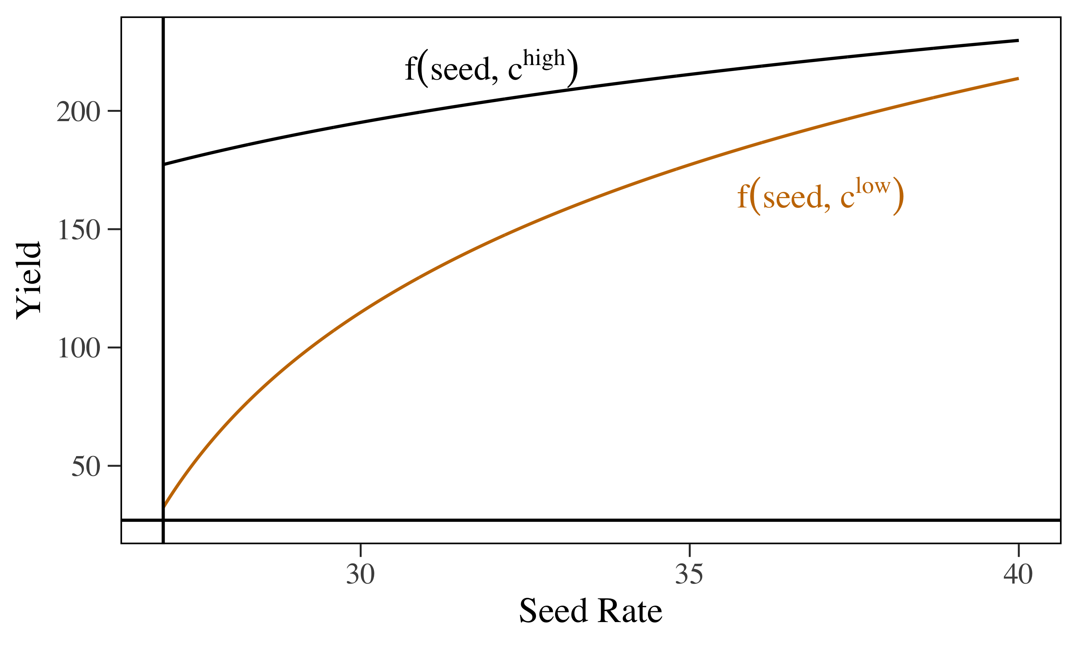

twi, tpi, elevation, slope, ecs were tested to see if they are correlated with the management zones. Among these variables, elevation seem to affect how yield responds to seed.

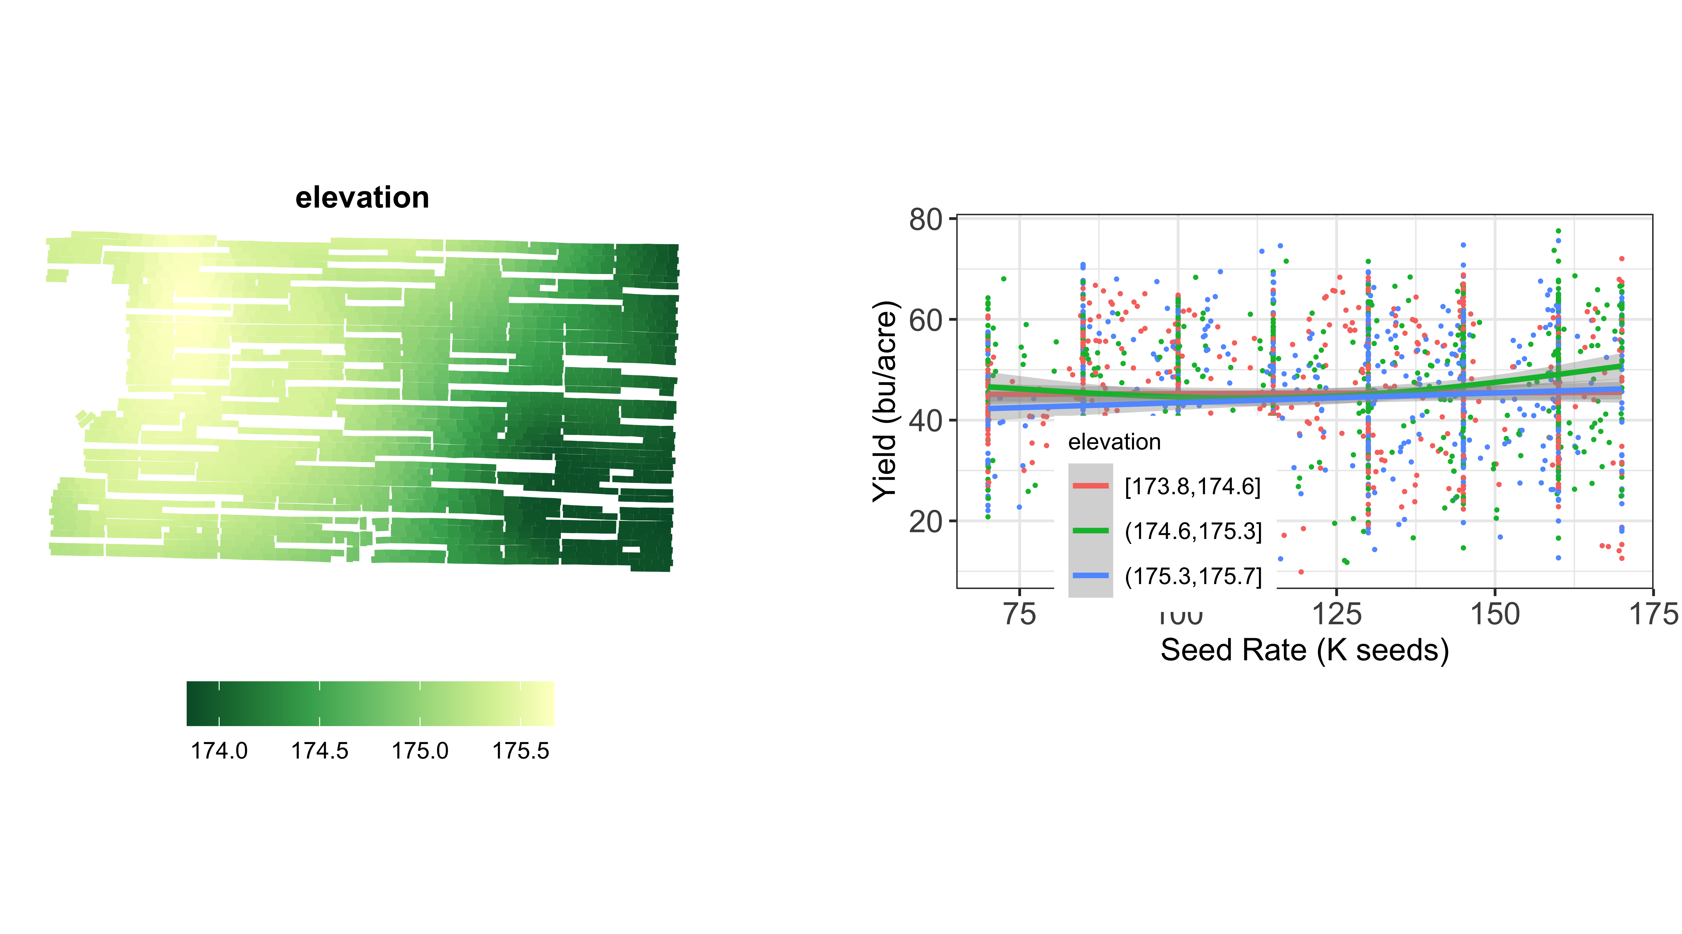

# Appendix: Overview of Data Processing

The variable-rate planter and yield monitor provided raw as-planted and harvest data. An initial cleaning removed observations with extreme yield or as-planted rates (“outliers”) from the raw data. Points were also removed from the headlands, where the data is less reliable due to differences in sun exposure, changes in driving speed, potential application overlaps, etc. The yield points were grouped into polygons using the distance between points, swath width, and the the headings recorded in the raw yield data. Subplots were created by grouping contiguous yield polygons with similar seed rates into sets of four. (Subplots were treated as the unit of observation in later analysis.)

A yield polygon was judged as having a “dominant treatment” when the standard deviation of the yield values at points within the polygon was below a threshold level. Adjacent as-planted polygons were judged as not being in the same group when the difference in application rates surpassed a threshold level. Polygons without a dominant treatment were not included in the data set used for analysis. This technique also helped eliminate "transition zones, which are areas in which the data show where the harvester and planter did not immediately adjust to new target rates or yield levels when passing from one plot into another. Each subplot’s mean as-planted rate and yield were recorded as data. Finally, for each subplot the means of the electrical-conductivity data, SSURGO soil data, and USGS digital elevation data were recorded. In addition the values topographical aspect, slope, curvature, topographical position index and topographical wetness index were calculated from the raw data, and each subplot’s means of these values were included in the data used for analysis. (Formal definitions of these topographical variables are available at .) Figure 8 shows maps of the processed yield and as-planted data. For more detailed explanation of data processing procedures, see

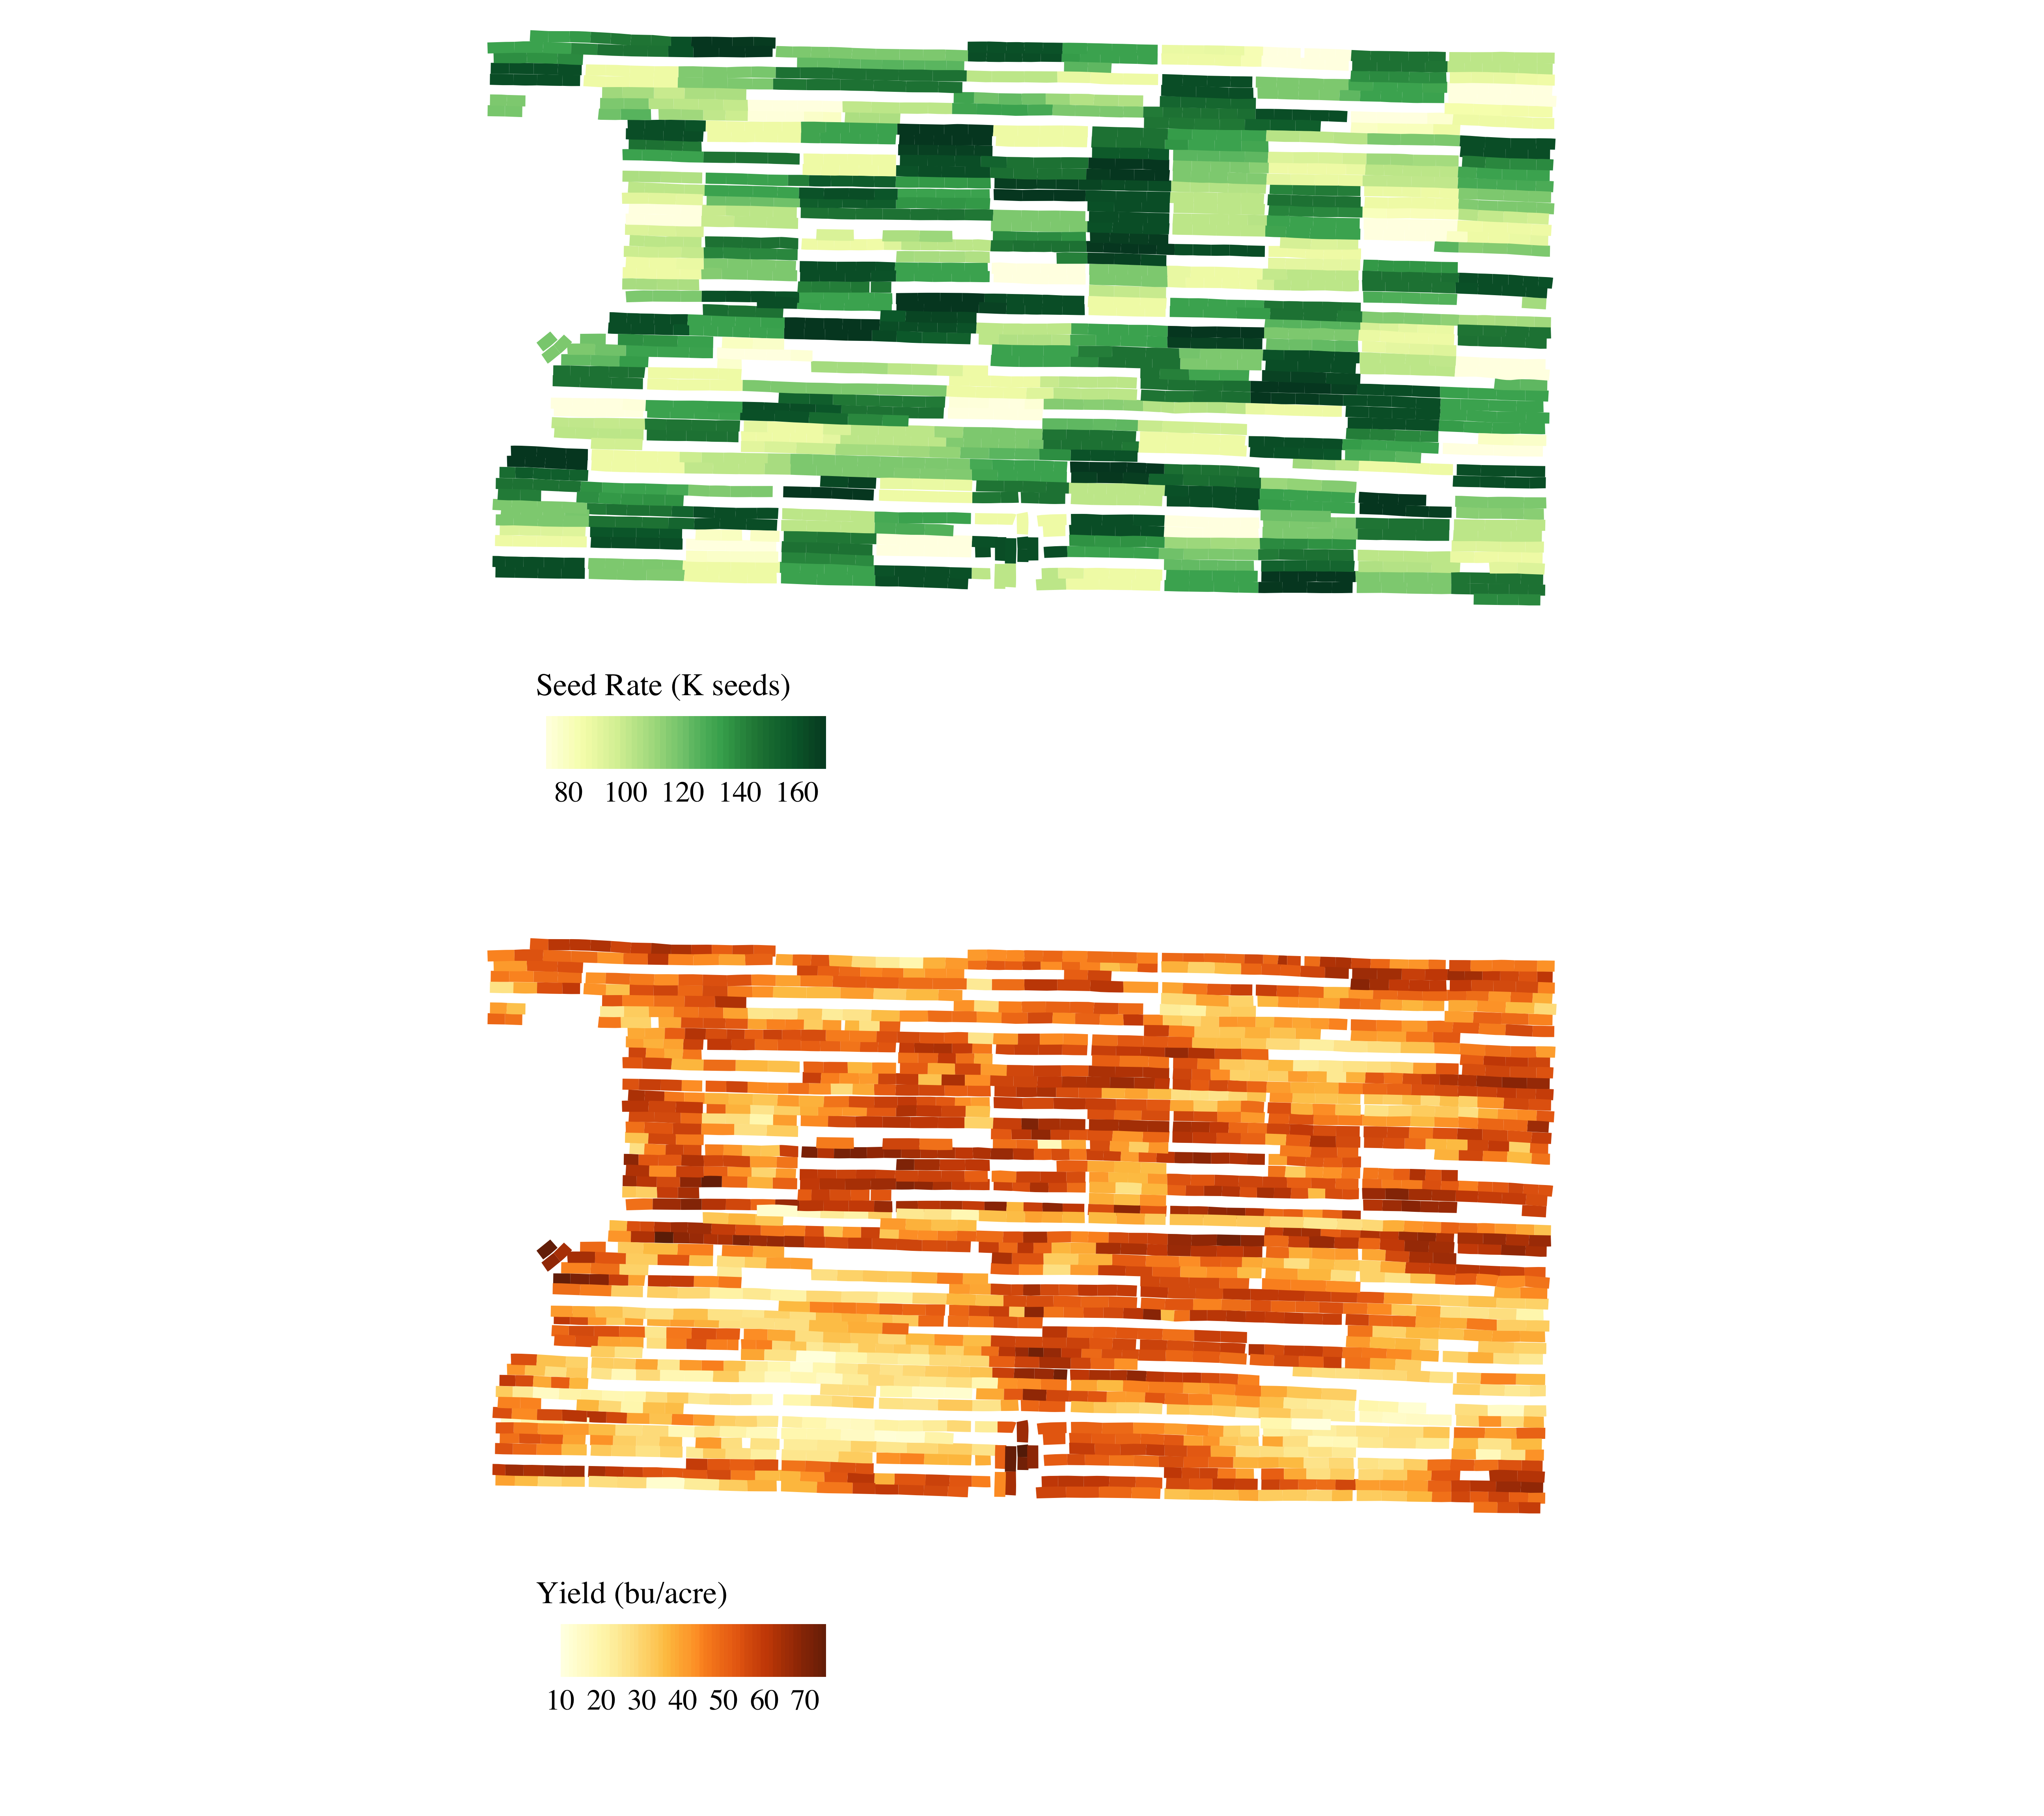

Figure 8: Yield and as-planted seed rates